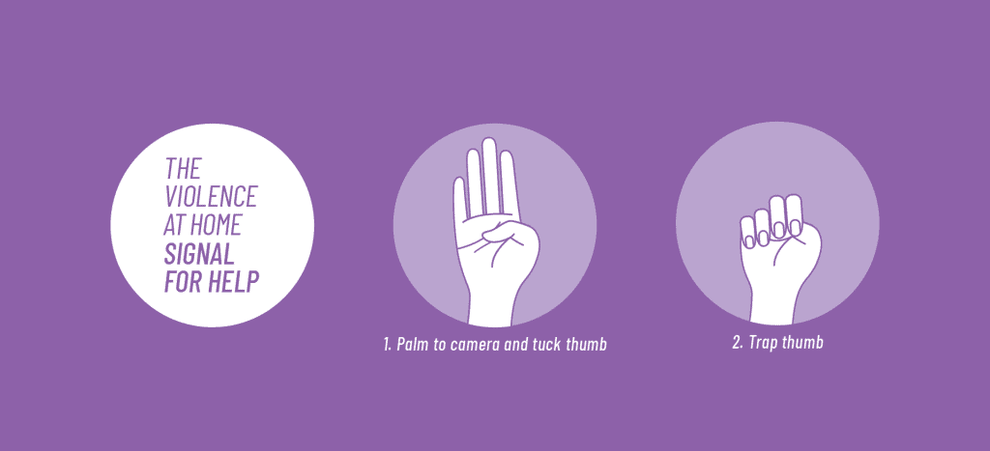

“Signal for Help” is a simple one-handed sign someone can use on a video call. It can help a person silently show they need help and want someone to check in with them in a safe way,

If You See the Signal:
If you see someone use the Signal for Help, check in with the person safely to find out what they need and want you to do.
They may want to tell you what is happening. They may ask you to listen and be there for them. They may ask for help finding services.
If you or someone you know is in immediate danger, call 999 or your local emergency services (police, fire, ambulance).

Some Ways You Can Check in Safely
Call them and ask questions that can be answered with “yes” or “no”. This may reduce risk if someone is listening. For example:
“Would you like me to call 999?”
“Would you like me to call a shelter on your behalf?”
“Should I look for some services that might help you and call you back?”
Use another form of communication such as text, social media, WhatsApp, or email and ask general questions. This may reduce risk if someone is watching the person’s device or accounts. For example, you can ask:
“How are you doing?”
“How can I help you out?”
“Get in touch with me when you can.”
Other questions you can ask:
“Do you want me to reach out to you regularly?”
“How else can I support you?”

Does the Signal for Help mean “call the authorities right away”?
No. It signifies “reach out to me safely.”
The person using the Signal may want a number of things. They may want to talk or they may want information. They may ask you to help them find services.
They may want you to call authorities, but do not assume that is what they want or need. Let them take the lead.
What if abuser learns about signal?

As the signal is shared and becomes known by the public, there is a risk that an abuser might learn about it. People in abusive situations are also often closely monitored by the person harming them, and they may not always feel safe enough to use the signal.
There is no one-size-fits-all solution for everyone facing abuse. Everyone faces their own unique circumstance. The Signal for Help is one tool some people may be able to use, some of the time, to indicate they need help without leaving a digital trace.
It is important that people reach out for support if and when they feel ready, and they should do it in the ways that feel safest for them. People supporting them should be ready to help without judgement, and they should follow the lead of the person who needs help.
SOURCE: https://canadianwomen.org/signal-for-help/

